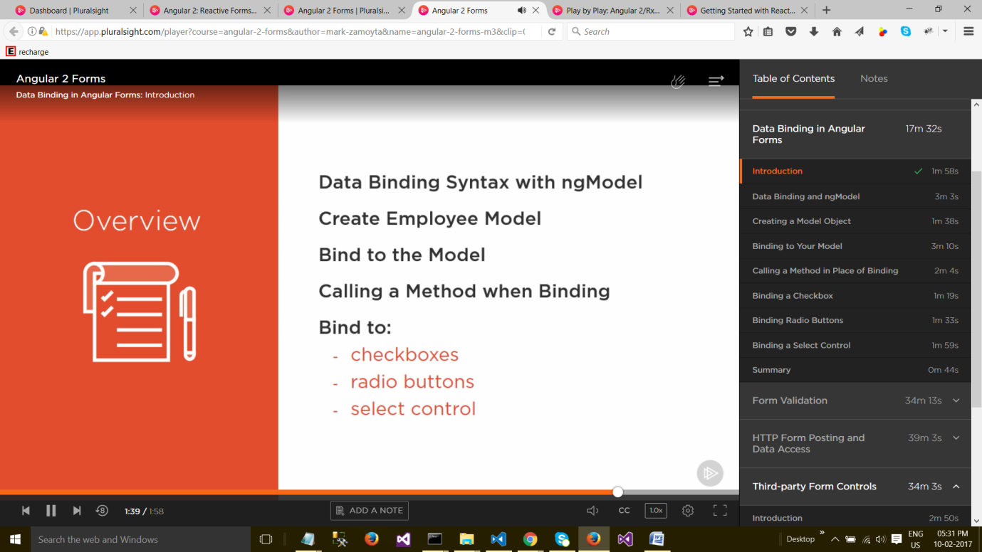

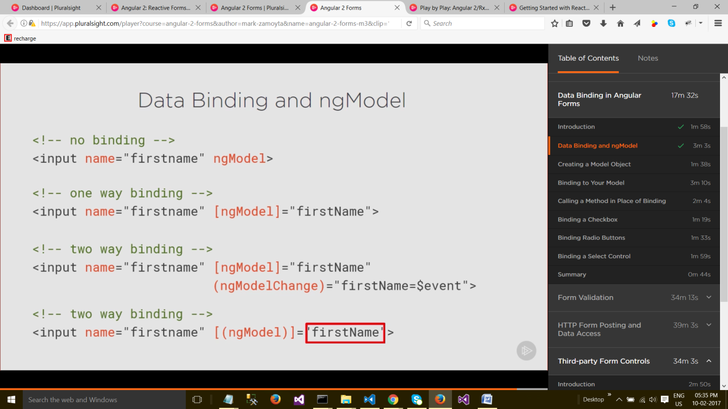

**Data Binding and ngModel**

So here's an example of no actual data binding going on. We have an input field and we give it a name, a first name. And we specify the ngModel directive. In this case, there's no data binding going on. However, because the directive is there, Angular will be aware of this field. **And it will use this field to build up its own internal object.** This object will have a property called "firstname". Because ngModel does require this name attribute to exist, so that it can build its own object. But as far as binding to our component goes, nothing will happen if we just leave the directive like this.

Now in this example, we have one-way data binding. Again, we have an input with the name of "firstname", but now we specify ngModel in square brackets. **So this is a property binding syntax.** **And we're setting ngModel to "firstName". So what this will do is it will look for a property of "firstName" on the TypeScript component and initialize this input field to "firstName",** whatever that value is. But as the form is filled out and the "firstName" changes, that won't reflect back in the component. This is only one-way data binding.

Now two-way data binding is similar to the last example, except now we're going to handle the ngModelChange event. You can see here ngModelChange is in parenthesis, showing that it's an event. And when this fires, when the input field changes, "firstName" will be set to $event, which happens to be the value in this case for the input**. So now we have two-way data binding.** **When the form is initialized, we'll grab "firstName" off the component and populate the form with it. And then as that "firstName" changes, we'll set "firstName" in the component to the input field's value.** And this is two-way data binding. However, there is a simpler syntax for this. It's referred to, in other Pluralsight courses, as a banana in a box syntax. We can merge the ngModel property and the event for ngModelChange into this syntax right here. It's called banana in a box, because you can think of the parenthesis being a banana and the square brackets being a box. And by setting that to "firstName", we get two-way data binding. And that's what we'll use most often in our forms. It's a short, compact syntax. And we just need to specify the model that we're going to use to hold the value. So "firstName" needs to exist on the component. In the rest of this course module, we'll take a look at using these various syntaxes for ngModel.

